19.18: a), b) The clockwise loop (I) encloses a larger area in the p-V plane than the counterclockwise loop (II). Clockwise loops represent positive work and counterclockwise loops negative work, so 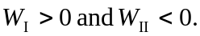 Over one complete cycle, the net work 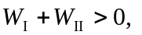and the net work done by the system is positive. c) For the complete cycle, 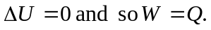 From part (a), W > 0 so Q > 0, and heat flows into the system. d) Consider each loop as beginning and ending at the intersection point of the loops. Around each loop, Heat flows into the system for loop I and out of the system for loop II.

